2018 FEBRUARY PROGRAM
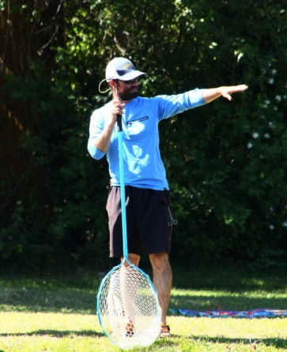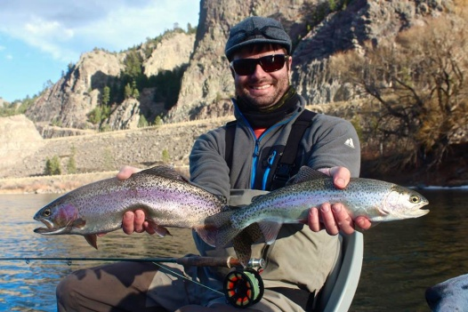
SPEAKER:
ONE OF OUR OWN –
BOB PRINCE

TOPIC:
BOB’S FAMOUS SLIDE SHOW

Come one, come all, come early to be sure that you get a seat for the world famous FFB slide show, organized and orchestrated by Bob Prince, teacher, musician, guide and former FFB president. Here is a chance to see friends and colleagues fishing and perhaps even catching fish. Photos will be augmented by an often witty, sometimes hilarious commentary. Come see the membership in action.

