June 2018 Program
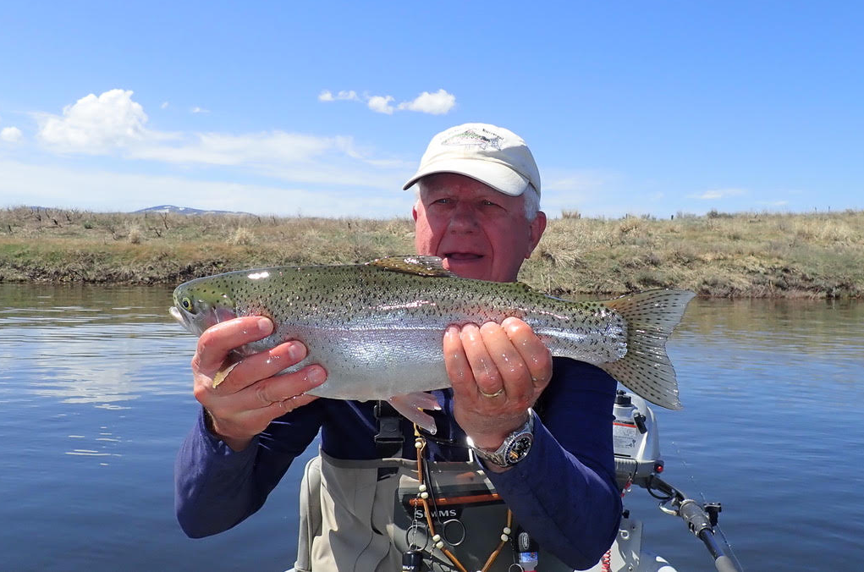
Guest Speaker
Our own famous club member
DENNY WESTOVER
Topic: LAKE FISHING
The June program is titled “Lake Fishing” and will focus on equipment, locating fish, and specific methods and techniques for fooling fish in still waters. Although there are numerous food sources available to trout in lakes we will concentrate on three of the most abundant and usually available sources – Chirionomids, leeches and Callibaetis mayflies. Although we will discuss several techniques for fishing imitations of each food source we will concentrate on a single technique that is effective for all three and is simple to learn and execute. Denny’s talk is accompanied by more than 75 photos of fly patterns, charts and equipment and will include practical examples of rigging for lake fishing.
Whether you are an experienced still water fisherman or a curious beginner there will be something for you in our June program. Join us on Tuesday, June 5 (5:30) at BJ’s Restaurant in Hamilton.
Denny is a member of Fly Fishers of the Bitterroot and has been fly fishing lakes, rivers and saltwater for more than fifty years. He is a summer resident of the Bitterroot (May to October) and then escapes to Sammamish, WA for the winter. Retired from the insurance business fifteen years ago he has ample time to devote to his fly fishing and wildlife photography hobbies

